**PO System**

**Login Screen**

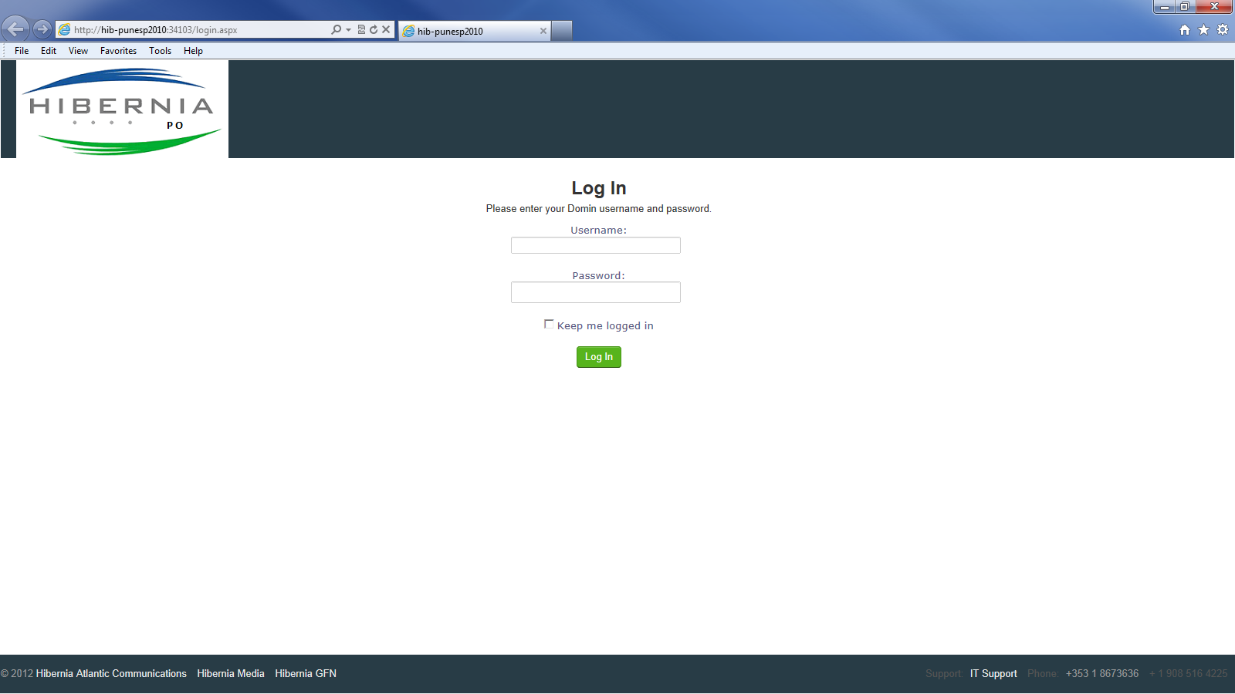

Login with UserID and password is your Windows password.

**Home**

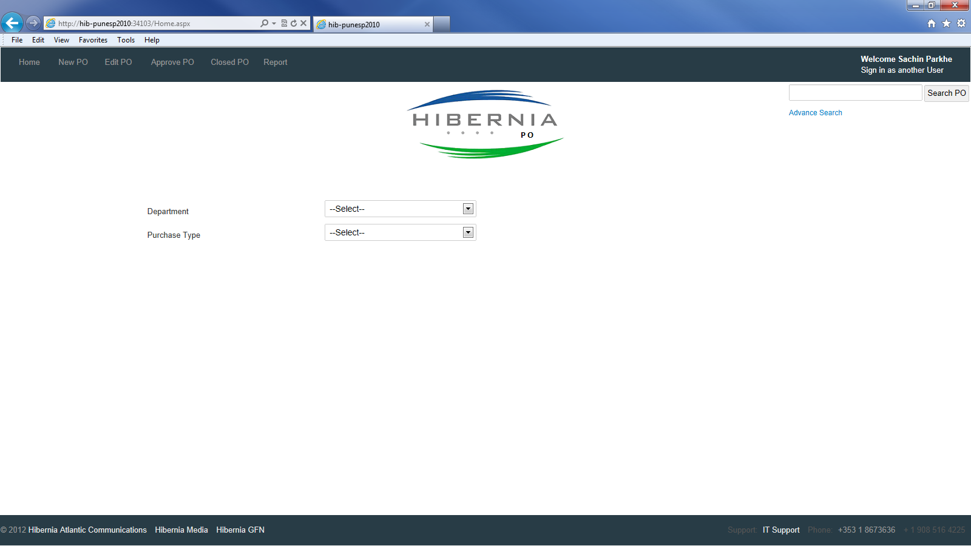

Select ‘Department’ from ‘Department’ drop down

Select ‘PO Type’ from ‘Purchase Type’ drop down

Page will be auto-redirected to New PO Page

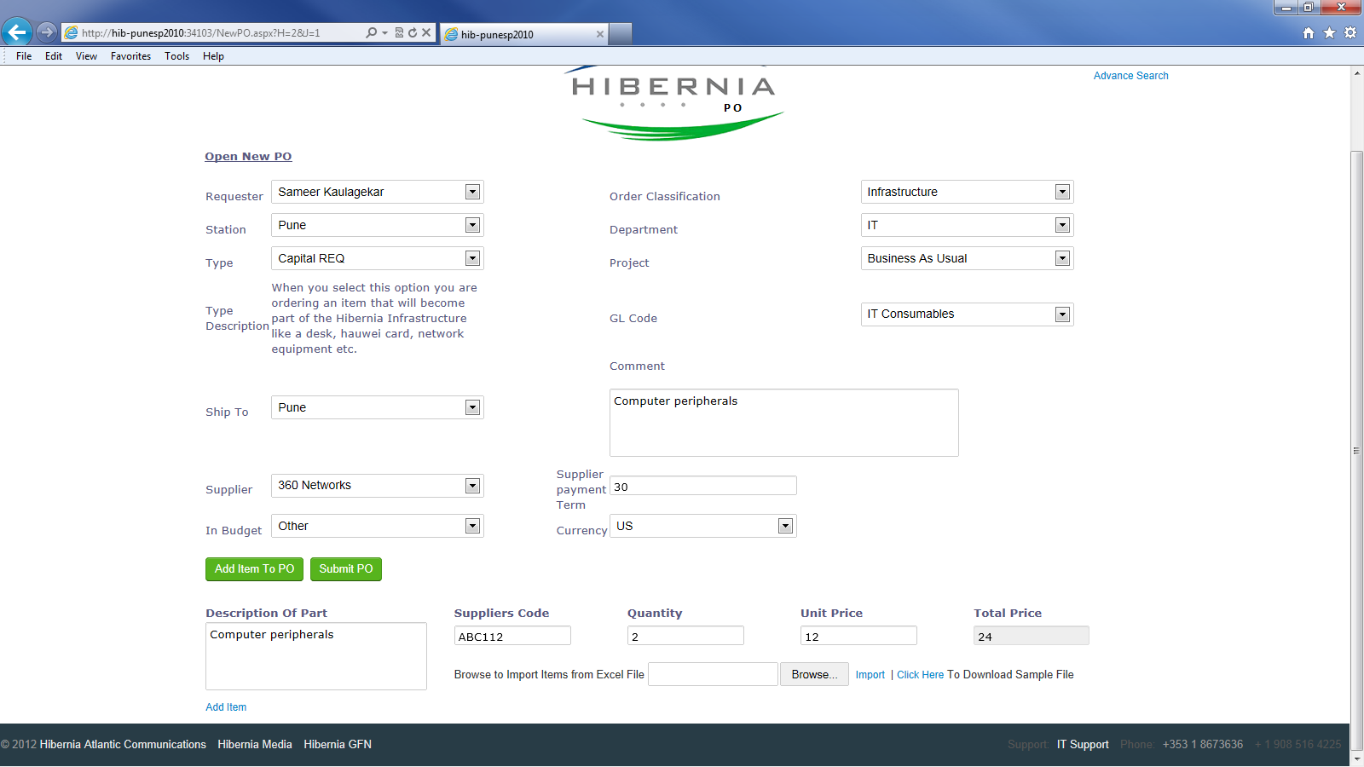

**EDIT PO**

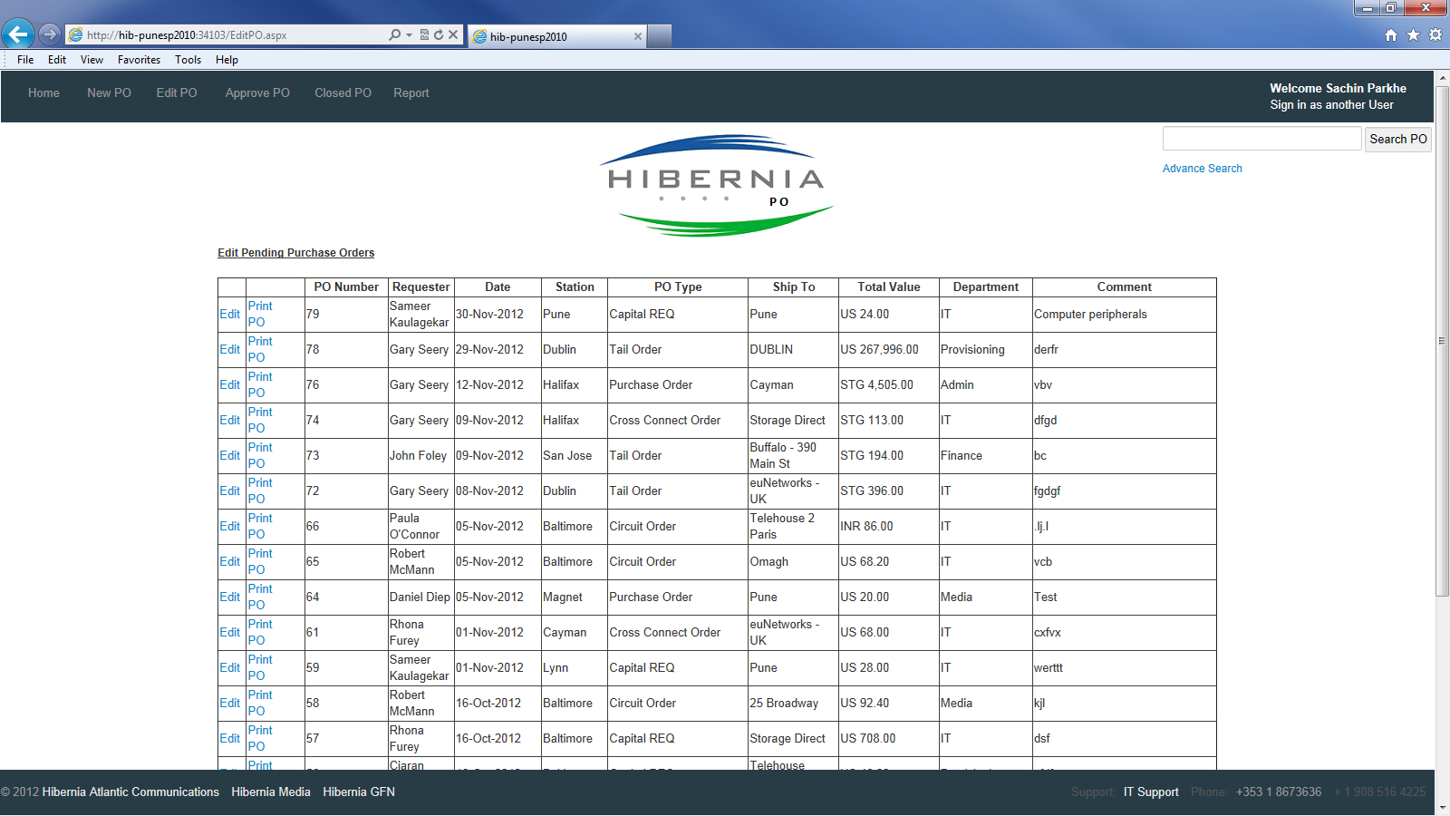

Click on Edit link🡪 Records of the PO is populated in New PO Page

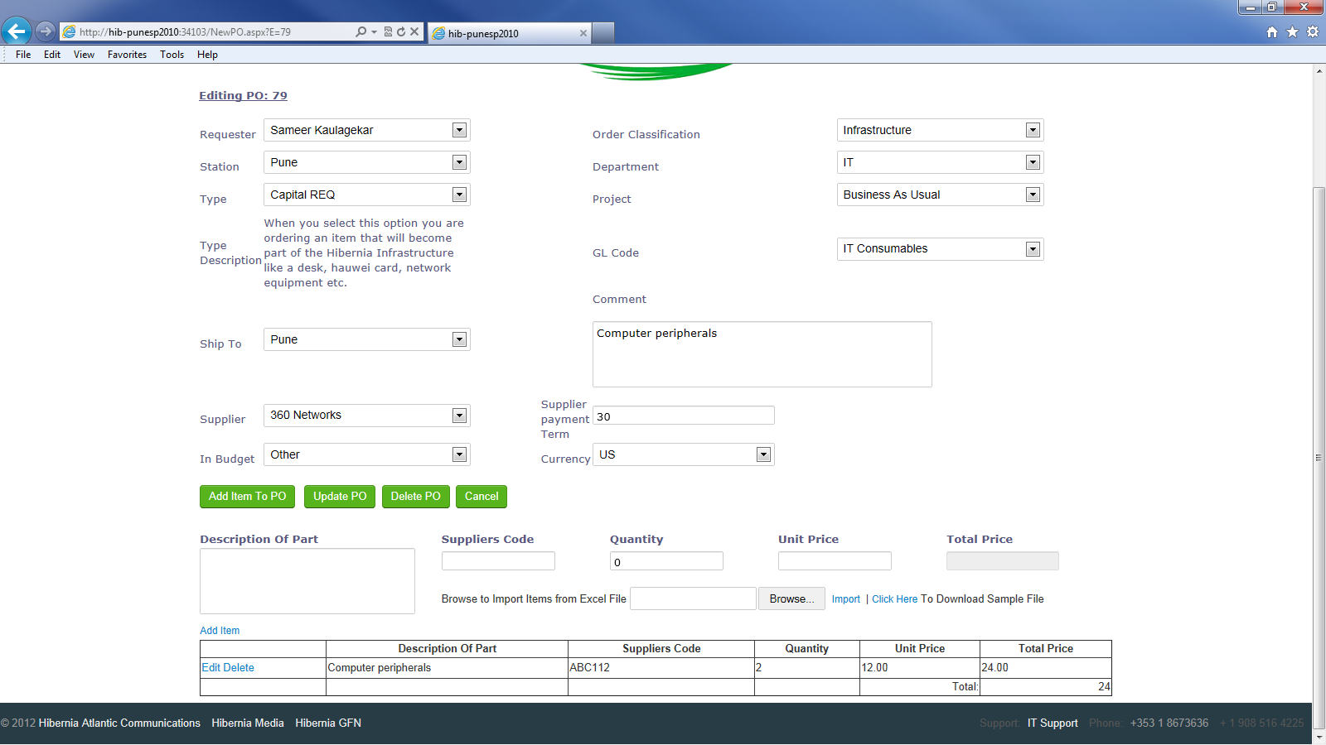

**Print PO**

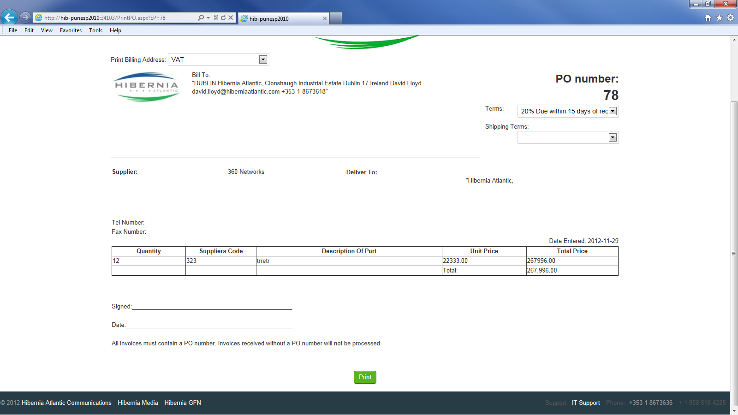

**Approve PO**

PO can be approved or rejected from this page

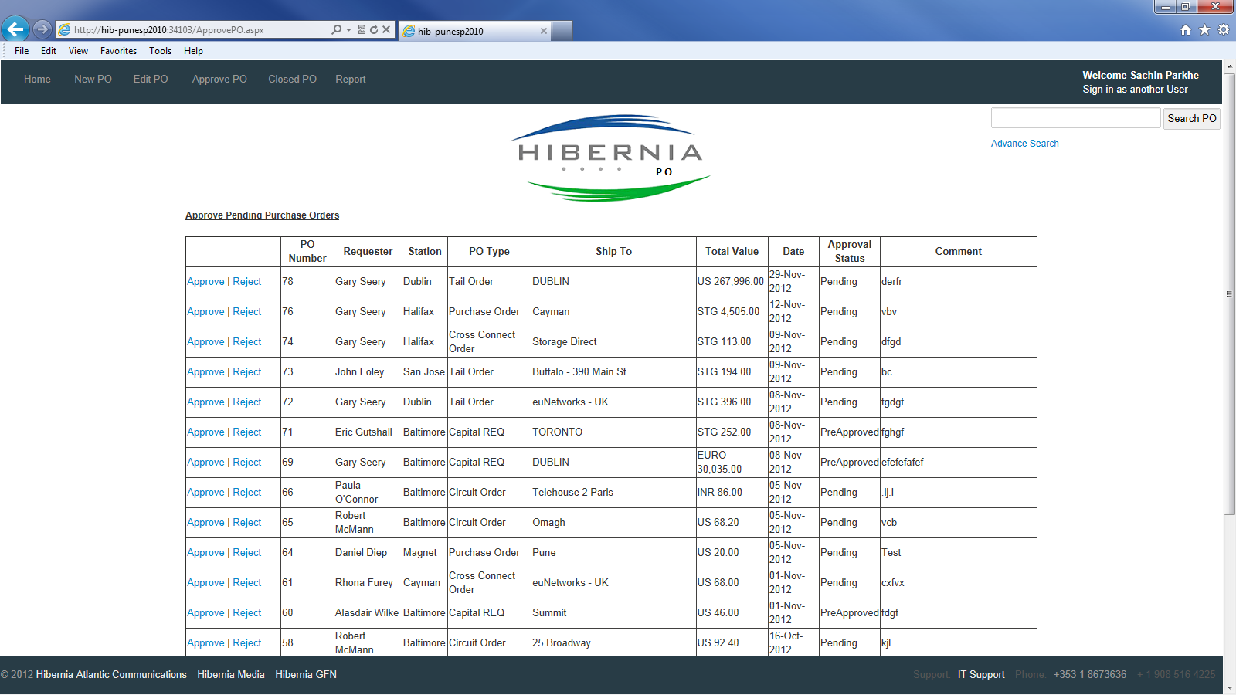

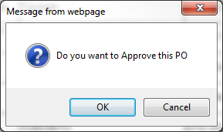

**Closed PO**

PO can be viewed, printed, reset in Pending status again, Received and Invoiced through this page.

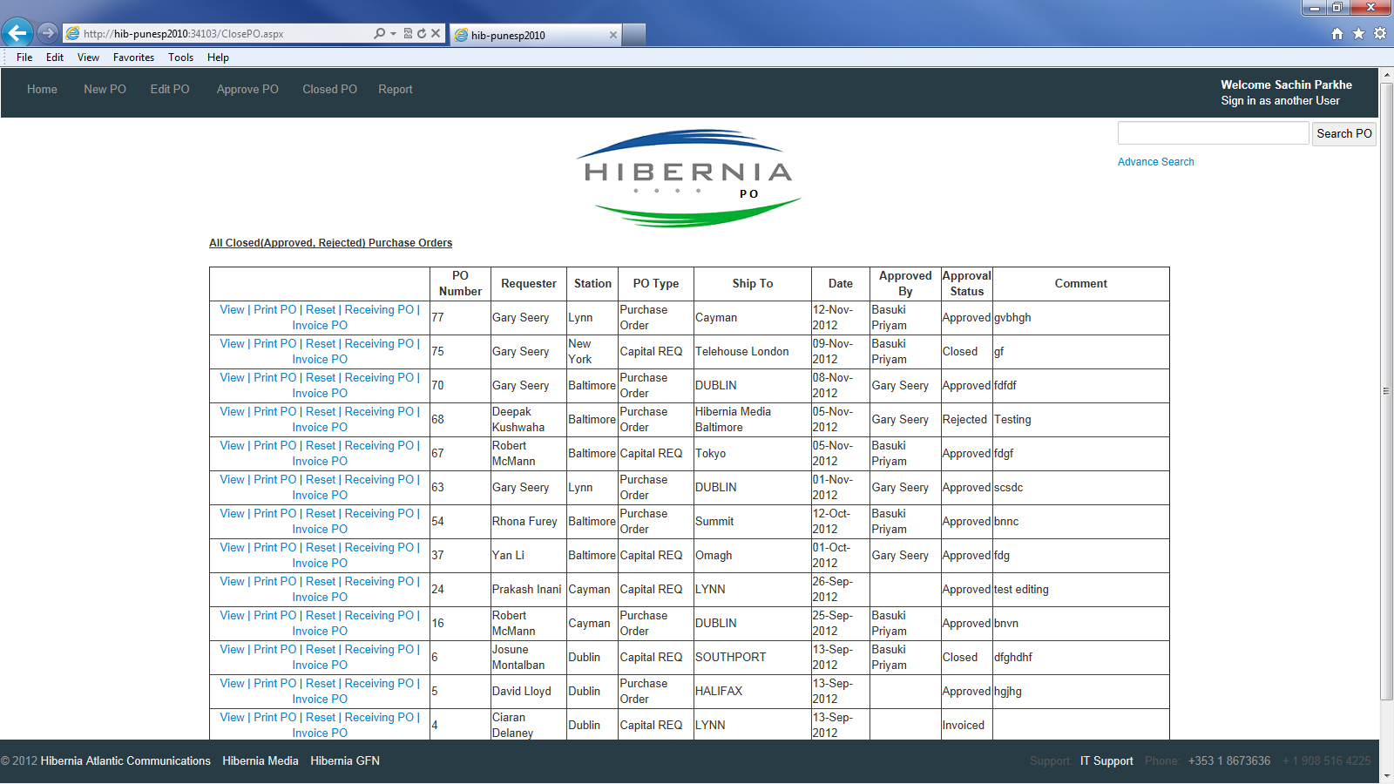

View PO: Click on View link in Closed PO page redirect to New PO page. But data is in read-only mode.

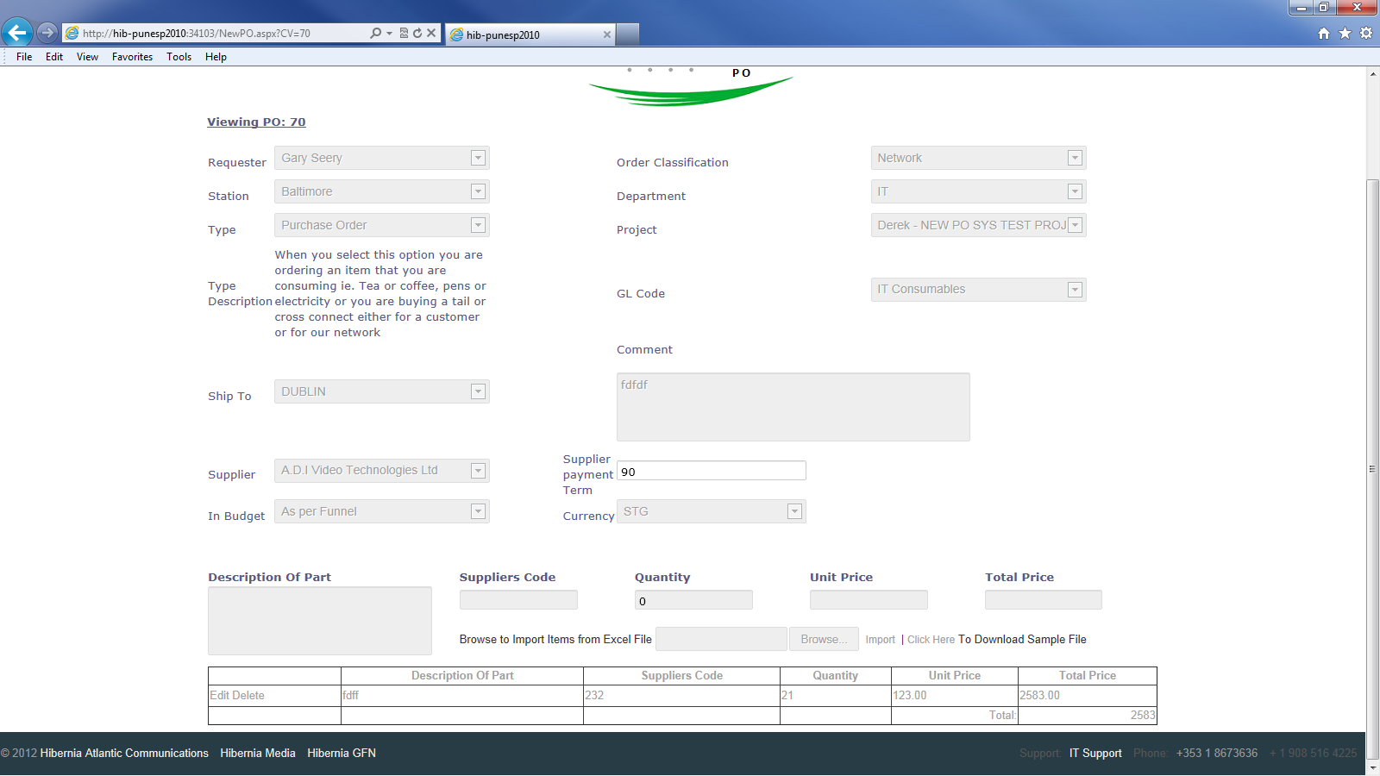

Receiving PO: Click on Receiving PO & Invoice PO link redirect to receiving page. Once PO is received then PO can be invoiced.

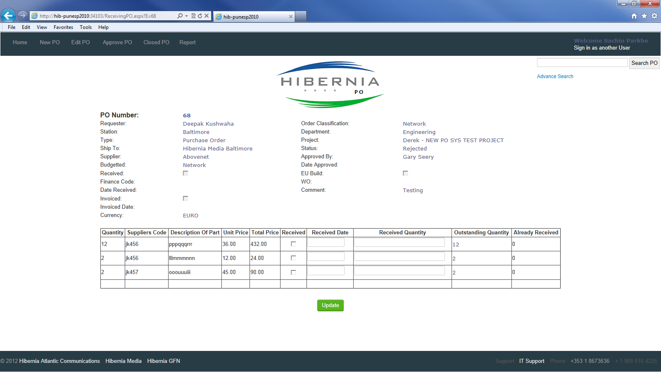

**Report**

In report section there are 3 reports, PO Summary, PO by Monthy and PO by Suppliers

